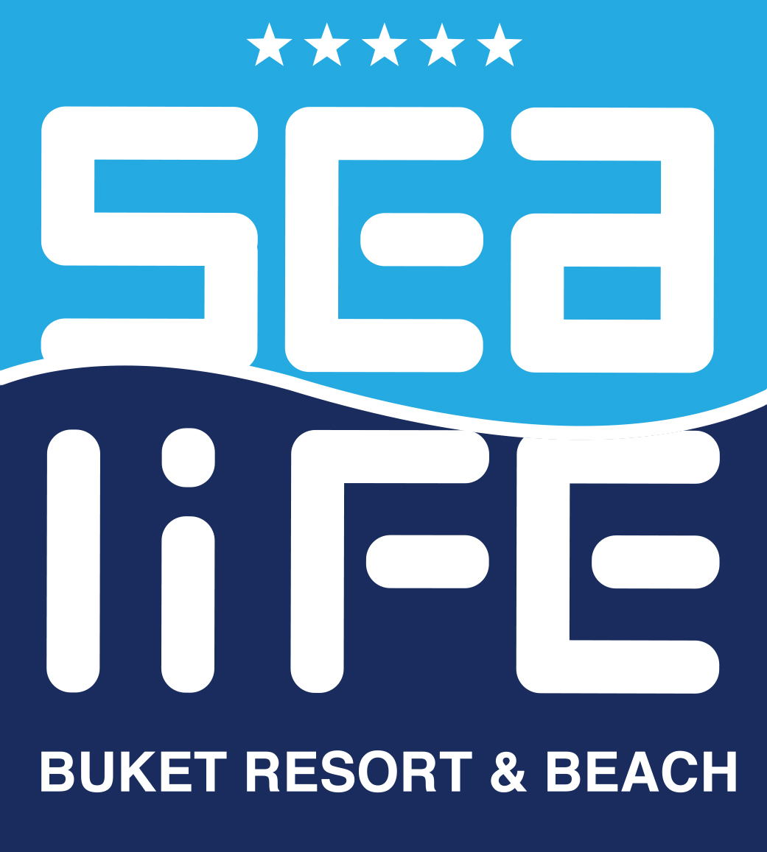

SEALİFE BUKET RESORT & SPA

ALL INKLUSİVE CONCEPT
2020 SUMMER

Drink & Food :
- Welcome Cocktail
- Lobby / Reception 24 hours. Coffe and Cake
- Minibar daily refreshing with Water and Softdrinks
- Roomservice ( with charge )

Buffet “Amber Restaurant”:
Breakfast : 07:00-10:00 (Main Restaurant)
Late Breakfast : 10:00-10:30 (Main Restaurant)
Lunch : 12:30-14:00 (Main Restaurant)
Dinner : 19:00-21:00 (Main Restaurant)
Midnight Snack : 23:30-05:00 (Main Restaurant)

Beverages Service “Amber Restaurant”:
Breakfast : Fruitjuice / Warm Drinks
Late Breakfast : Fruitjuice / Warm Drinks
Lunch : Soft / Warm Drinks / Local Alcoholic Drinks*
Dinner : Soft / Warm Drinks / Local Alcoholic Drinks*
Midnight Snack : Fruitjuice ,Coffee, Water
* Local Alcohol Drinks ; Rakı, Gin, Wodka, Wine, Beer (Glass )
- Breakfast / Lunch/Dinner/ Show Buffet
- Diet Buffet (Main Restaurant)

A’la Carte Restaurants (19:00-21:00)
(min. 1 day before reservation)
“Turkuaz Restaurant” - Turkish Kittchen
‘’Sapphire Restaurant ‘’ -Italian Kittchen
‘’Mavi Restaurant ‘’ - Fish Kittchen

A’la Carte Restaurants Beverage Service (19:00-21:00)
Soft Drinks, Local Alcoholic Drinks*

* Local Alcoholic Drinks; Rakı, Gin, Wodka , Wine, Beer (Glass)

Bars:
CINNABAR : 10:00-24:00 Soft/ Warm and Local Alcoholic Drinks*
VIEW BAR : 10:00-24:00 Soft/ Warm and Local Alcoholic Drinks *
SNACK BAR: 10:00-18:00 Soft/ Warm and Local Alcoholic Drinks *
Azur Bar : 10:00 – 17:00 Soft Drinks
DISCO : 24:00-02:00 Soft & Alcoholic Drinks( with charge )

Snack :
Snack bar 12:00-16:00
Filled Pasta 11:00-16:30
Coffee & Cake 12:00-17:00
Ice Cream 12:00-16:45
Baked Potato 12:00-17:00
Sweet(Lokma) 17:00-18:00

* Local Alcoholic Drinks ; Rakı, Cin, Wodka, Wine, Beer (Glass)
*Daily alcohol and alcoholfree cocktails at View Bar .

For Kids:
- Mini Disco / Mini Shows / Playground/Children Buffet ( 18:30-19:00)

FİTNESS:
- Fitness Room
- Turkish Bad and Sauna
- Aerobik, Water Gymnastik, , Water Games
- Tenniscourt
- Tennis (equipment with charge )
- 2 Pools (1 with slides)
- Basketball, Beach Voleyball , Tabletennis , Boccia, Dart
- Waterpolo / Waterrsport
- Indoor pool

Entertainment:
- Amphytheater (Arena)
- 6 time the week Animation
- One time in week live music
- Daily Animation Show
- Entertaiment after the evening Shows
- Disco (24:00-02:00)
- Cinema
- 2 theme evening in the Main Restaurant

Other Equipments:
- Pool/ Sunbeds , Sunumbrellas , Beachtowels
- Meetingroom with Equipment
- Free wi-fi connection
Service with charge :
- Laundry Service
- Internet Cafe
- Billard in Game Room / Aero hockey / Play Station
- Babysitter
- Telefon / Fax
- Doktor Office
- Spa Wellness / Beauty Center and Coiffeur
- Watersport (jet ski, banana, Parasailling.)
- All kind of export alcoholic beverages
- Roomservice
- Fresh Orange Juice
- Tennis equipment , Tenniscourt lighting
- Projektor in Meetingroom
- Shops and Photographer
- Safe box

