KIMEROS PARK HOLIDAY VILLAGE
Goynuk / Kemer /Antalya
ULTRA ALL INCLUSIVE SUMMER 2020 FACT SHEET & CONCEPT

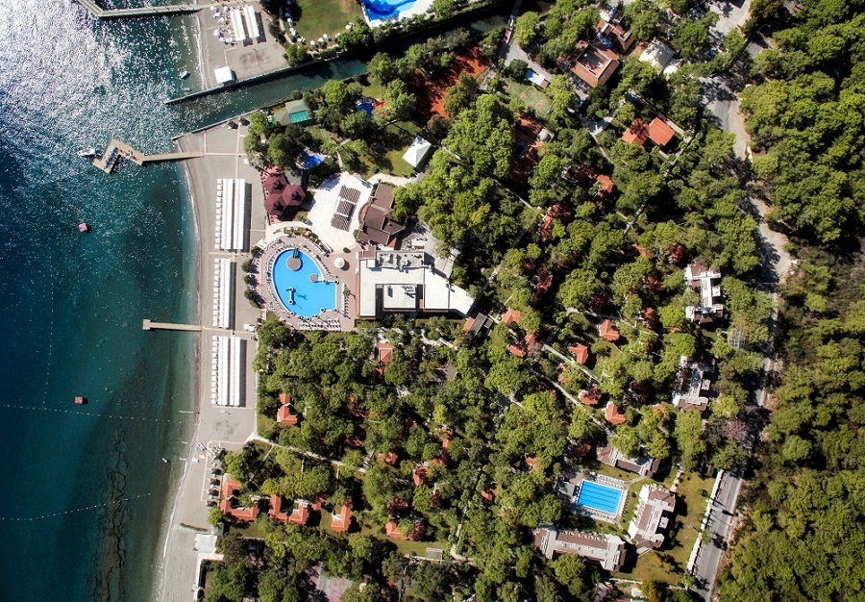

GENERAL INFORMATION
Hotel’s name | KİMEROS PARK HV 1
Class | HV 1 – 5 STARS
Address | Göynük Mahallesi, Ahu Ünal Aysal cad. No: 41  07994 Göynük / Kemer - Antalya - TURKEY
Postal Address | P.K. 07994 Kemer - Antalya – TURKEY
Phone | + 90 242 815 18 88 / 54
Fax | + 90 242 815 18 76 (Rezervasyon)
E-Mail | info@kimeroshotels.com
General Manager | Özgür MUSLU
Sales & Marketing | Mithat GÜNGÖR mgungor@kimeroshotels.com
Reservation | reservation@kimeroshotels.com
Year of opening | 1985
Renovation | 2016 General
Area | 97.000 m2
Number of rooms 442 | Number of beds |  | 1076
Garden Room, NO of floors | 2 Floors
Kimeros Room, NO of floors | 3 Floors
Number of elevators | NO
Beach | Blue Flag, Small pebble and natural sand
Airport | Antalya Airport 46 km
Hospital | Kemer 6 km
Historic Venuse | Phaselis 12 km, Olimpos 50 km
Shopping Center | Goynuk 1 km
Transportation | Every 20 minutes from the main road, Phaselis, Olympos, Tekirova, Çamyuva, there are minibuses to Kemer and Antalya .
Parking | Open Air, 100 Cars
Credit cards | Visa, Mastercard
Pets | Not accepted

WELCOMING AT KIMEROS PARK

Welcoming all guest at the door | Raincoat service on rainy days
Turkish delihgt, dried friuts and lemonade during chechk-in (09:00 – 17:00 o’clock) | Appropriate arrangements for disabled guests in public areas

ROOMS
ROOM TYPES |  | GARDEN ROOM | GARDEN SUIT |  |  | KIMEROS STANDART  ROOM FOR DISALED |  | KIMEROS STANDART |  | KIMEROS  FAMILY
Number of Rooms 442 |  | 222 | 28 |  |  | 4 |  | 92 |  | 96
TYPE OF BEDS |  | FR  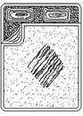  SOFA | FR |  |  | TWİN  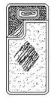 |  | TWİN |  | FR  TWIN
TYPE OF BEDS |  |  | SOFA
m2 |  | 26 | 31 |  |  | 26 |  | 26 |  | 33
Bedroom |  | 1 | 1 |  |  | 1 |  | 1 |  | 2
Living Room |  |  | 1
LED TV
Direct Dial Phone in Bed&Bath rooms
Minibar
Hot Set-up
Indıvidual Split System,
Safe Box
Ceramic floor
Hair Dryer
Bathroom with shower
Sofa Bed |  | 1 | 2
Balkony / Terase |  | Balkony | Balkony |  |  | Balkony |  | Balkony |  | Balkony
View |  | Garden | Garden |  |  | Garden |  | Garden |  | Garden

ROOM SERVICES
 |  | ROOM CLEANING |  | LINEN CHANGE |  | TOWEL CHANGE |  | BEACH TOWEL CHANGE
Every day |  | Every day |  | 3 days in a week |  | Every day |  | Once a day
MINIBAR |  | Free |  | All drinks refilled once a day  * Water *Fanta  * Cola *Sprite  * Mineral Water *Fruit juice

GARDEN ROOMS : 222 Rooms, 26 m2, 3 Adults or 2 Adults 1 child + 1 baby accomodation, garden and mountain view,1 bedroom (french) + sofa bed,1 bathroom with shower, balkony, telephone, safe box (free), ceramic floor, cabel TV, slippers, tea set-up, individual spit sistem , LED TV. Wi-fi

GARDEN SUIT ROOMS: 28 rooms, 31 m2, 4 adults or 2 adults 3 children accomodation, garden and mountain view , 1 living room (2 sofa bed) with separated door, 1 bedroom ( french bed), balkony, telephone, safe box (free), ceramic floor, cabel TV, slippers, tea set-up, individual spit sistem, LED TV. Wi-fi
*FAILY TERRACE : 6 Oda, 36 – 38 m2, Deniz manzara,1 yatak odası1 oturma odası, 1 k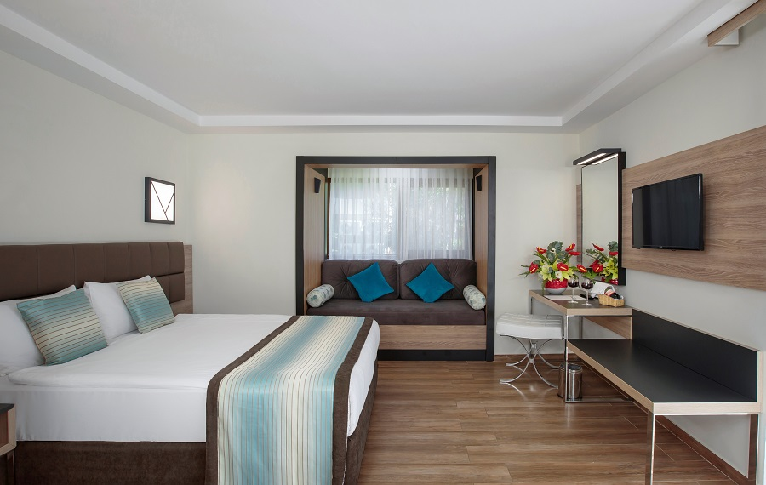t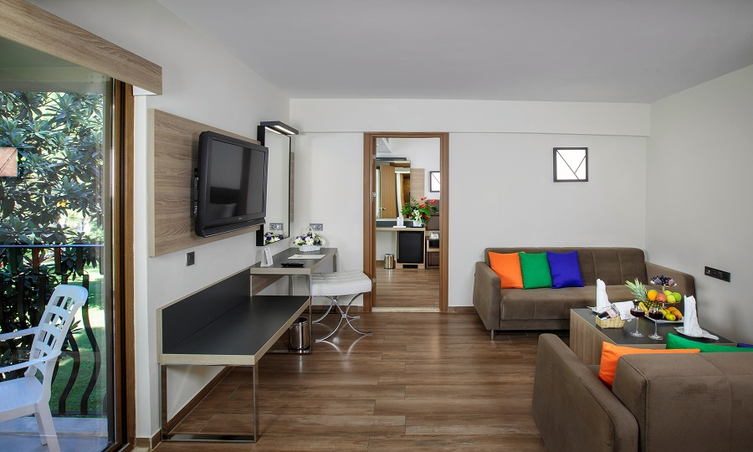sa merkezi klima
KIMEROS STANDART : 96 rooms, 26 m2, 3 adults or 2 adults + 1 child accomodation, garden and mountain view,1 bedroom (twin bed),1 bathroom with shower, balkony, telephone, safe box (free), ceramic floor, cabel TV, slippers, tea set-up, individual spit sistem, LED TV. Wi-fi

KIMEROS FAMILY ROOMS: 96 rooms , 33 m2, 4 adults or 4 adults + 1 baby accomodation, garden and mountain view , 2 bedrooms (french and twin) with separated door, 1 bathroom with shower, balkony, telephone, safe box (free), ceramic floor, cabel TV, slippers, tea set-up, individual spit sistem, LED TV. Wi-fi
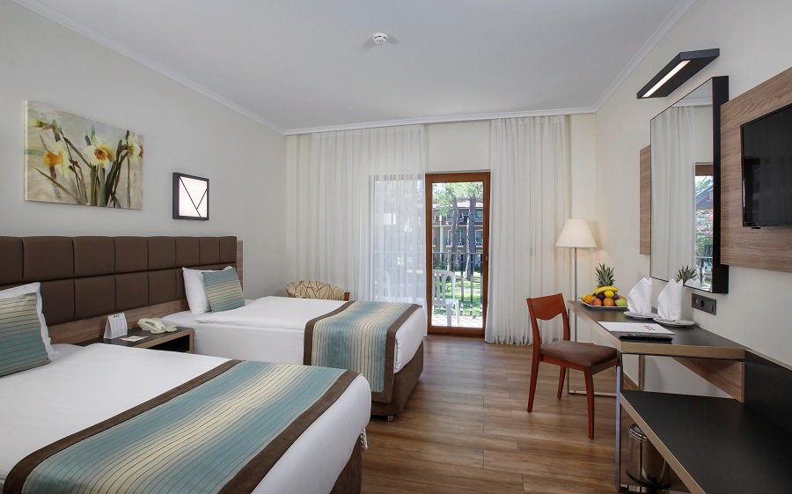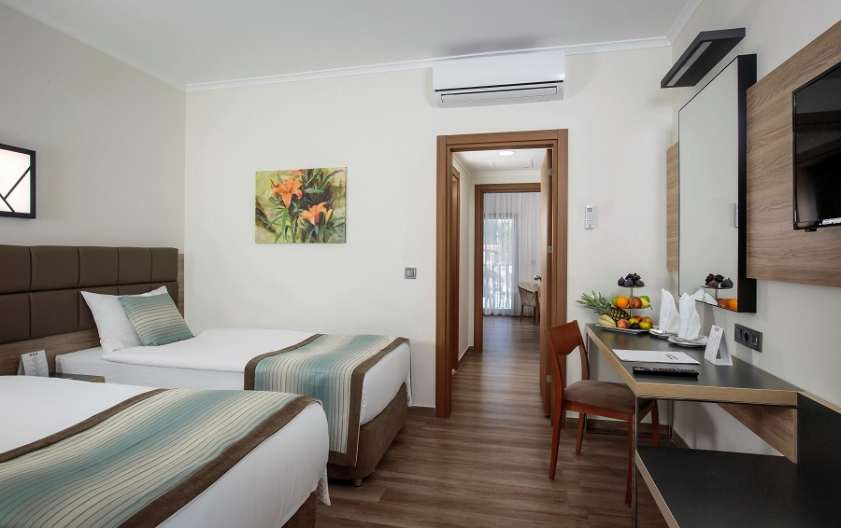

HONEYMOON SET-UP
SERVICE | FREE | CHARGE
Special Room decoration | √
Fruit plate, Turkish delight | √
A bottle of wine | √
Complimentary breakfast served in the room the day after arrivel | √

REPEAT GUEST SET-UP
SERVICE | FREE | CHARGE
Fruit plate | √
A bottle of wine | √
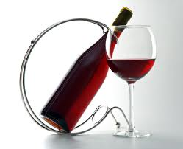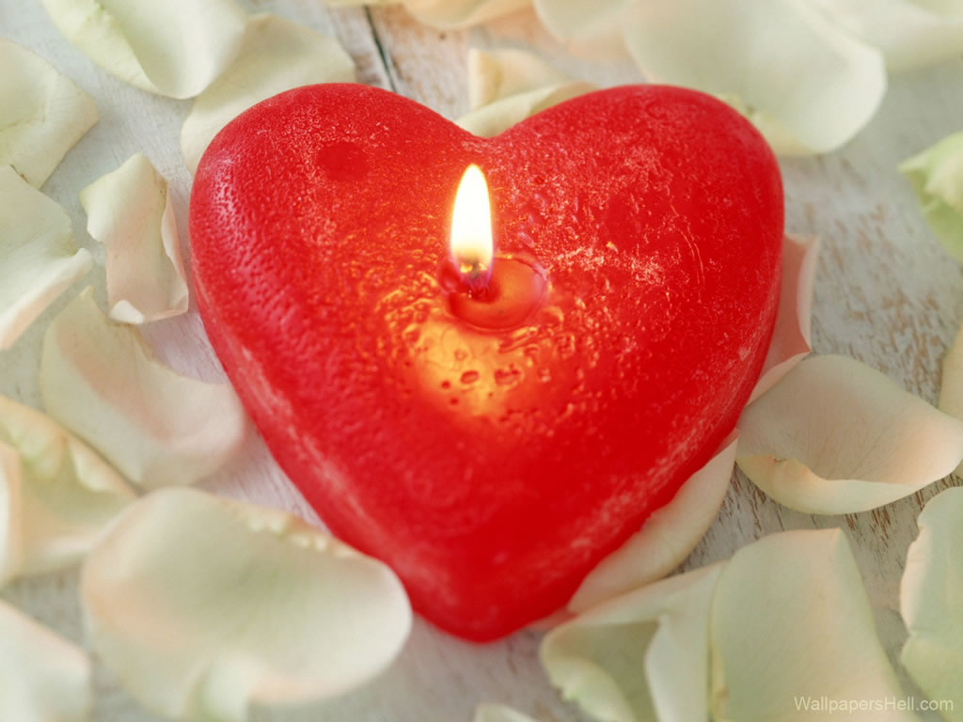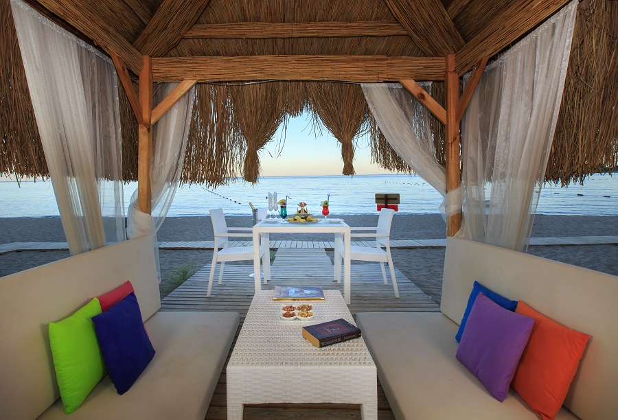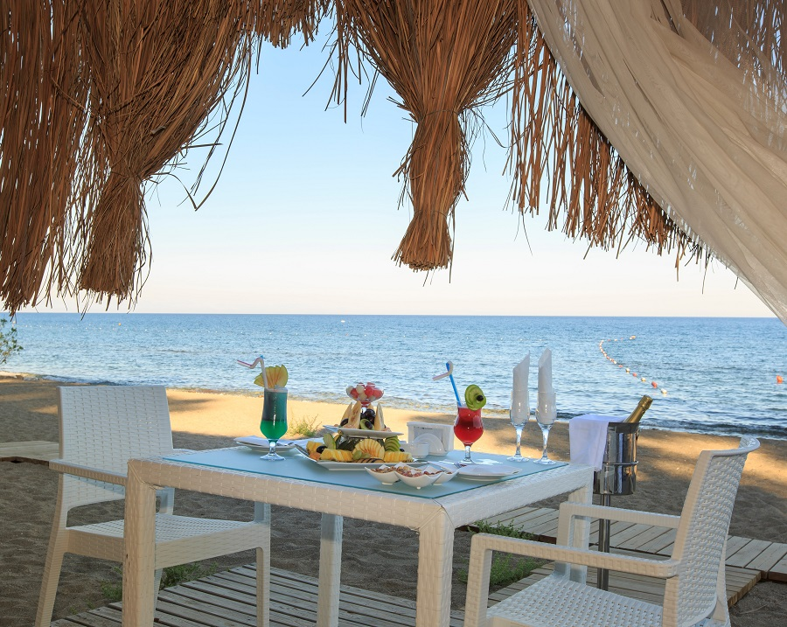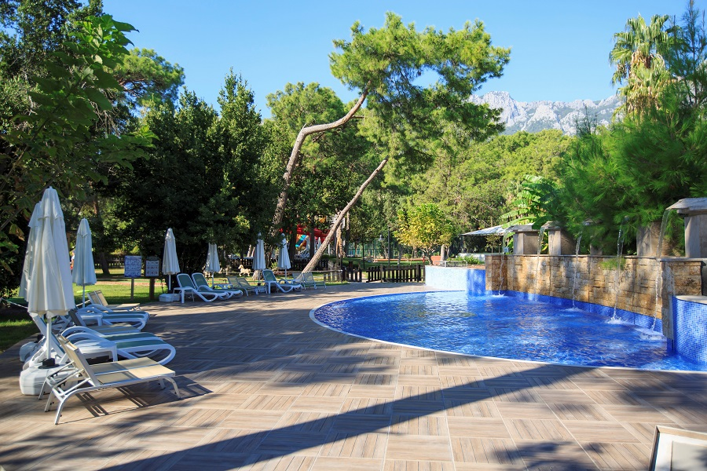
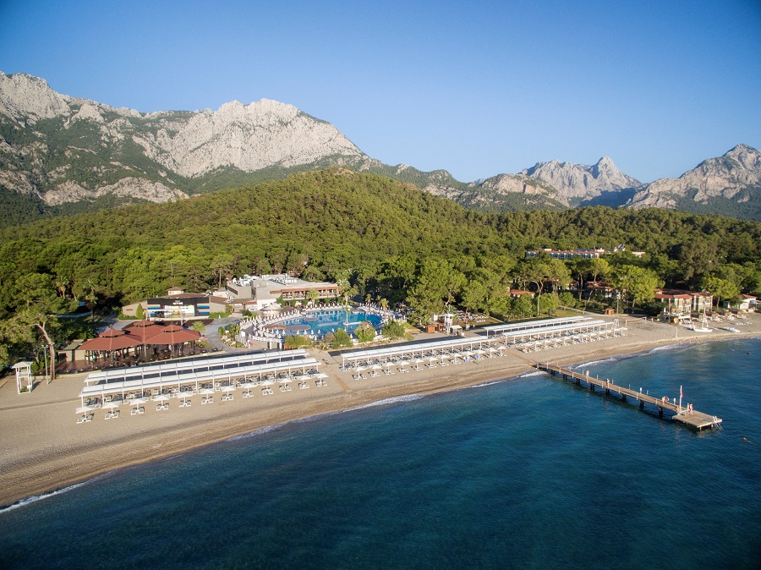
OTHER SERVICES | FREE | CHARGE
Market |  | √
Rent a car |  | √
Other Shops |  | √
Wheelchair |  | √
Baby stroller & baby phone |  | √
WI-FI in the rooms | √
Special celebration organizations |  | √
Doctor & Nurse |  | √
Lundry and dry cleaning |  | √
F&B SERVICE

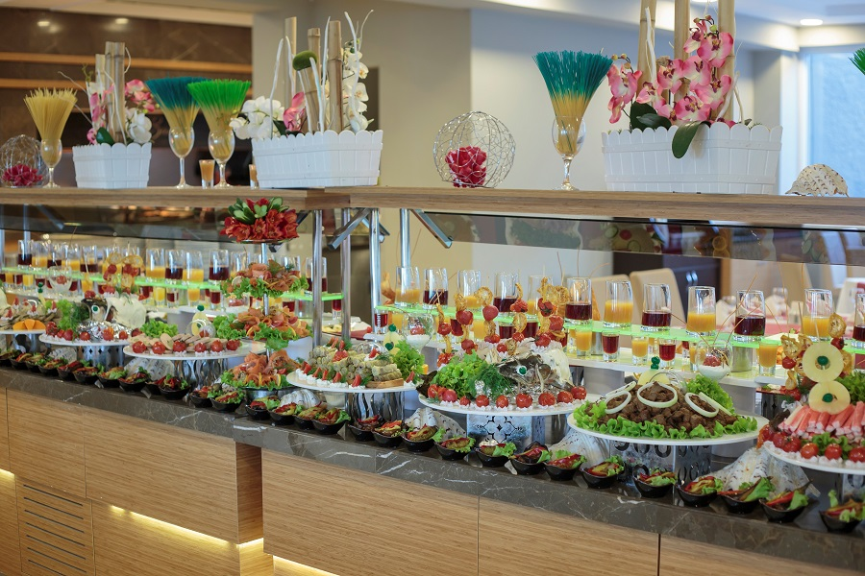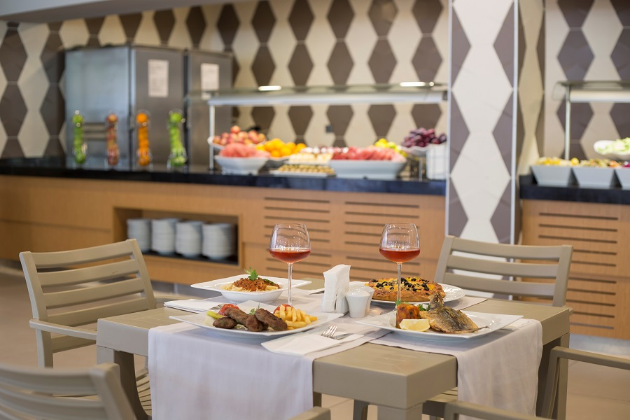

MEAL | SERVICE HOURS | PLACE
MEAL | SERVICE HOURS | PLACE | FORM OF REP. | UAI
Breakfast | 07:00 – 10:00 | Main Restaurant-Buffet  Diet & Children Buffet Buffet | Open Buffet | √
Late Breakfast | 10:00 – 11:00 | Main Restaurant | Open Buffet | √
Lunch | 12:30 – 14:00 | Kimeros Avenue | Open Buffet / A la Carte / Self Service | √
Dinner | 19:00 – 21:00 | Main Restaurant-Buffet  Diet & Children Buffet Buffet | Open Buffet | √
Late dinner | 24:00 – 06:00 | Kimeros Avenue | A la Carte Open Buffet | √
Snack | 11:00 – 18:00 | Kimeros Avenue | Self Service | √
Gözleme | 11:00 – 16:00 | Kimeros Avenue | Self service | √
Patisseries | 11:00 – 24:00 | Lillyum Patisserie | Self service | √
Ice cream | 12:00 – 18:00 | Lillyum Patisserie | Self service | √
A la Carte Restaurant | 19:00 – 21:30 | A la Carte Restaurant | A’la Carte | Extra, Reservation is requested

 | SERVICE HOURS |  | Ultra All Inclusive
LOBBY BAR | 09:00 – 18:00 |  | * Cola, Diet Cola,Fanta, Sprite, Ayran, Türkish Coffee, , Tea, Types of Herbal Tea, Water.
RELAX POOL BAR | 10:00 – 18:00 |  | * Whisky, Vodka, Gin, Brandy, Liquer, Rom, Tequila, Beer, Rose Wine, White Whine, Red Wine, Champagne, Rakı, Alcoholic Cocktails.  * Cola, Diet Cola,Fanta, Sprite, Ayran, Türkish Coffee, , Tea, Types of Herbal Tea, Water
POOL BAR | 00:00 – 24:00 |  | * Whisky, Vodka, Gin, Brandy, Liquer, Rom, Tequila, Beer, Rose Wine, White Whine, Red Wine, Champagne, Rakı, Alcoholic Cocktails.  * Cola, Diet Cola,Fanta, Sprite, Ayran, Türkish Coffee, , Tea, Types of Herbal Tea, Water
LOTUS BEACH DISCO CLUB | 23:00 – 02:00 |  | * Whisky, Vodka, Gin, Brandy, Liquer, Rom, Tequila, Beer, Rose Wine, White Whine, Red Wine, Champagne, Rakı, Alcoholic Cocktails.  * Cola, Diet Cola,Fanta, Sprite, Ayran, Türkish Coffee, , Tea, Types of Herbal Tea, Water
LOTUS BEACH BAR | 10:00 – 23:00 |  | * Whisky, Vodka, Gin, Brandy, Liquer, Rom, Tequila, Beer, Rose Wine, White Whine, Red Wine, Champagne, Rakı, Alcoholic Cocktails.  * Cola, Diet Cola,Fanta, Sprite, Ayran, Türkish Coffee, , Tea, Types of Herbal Tea, Water
SPA VITAMIN BAR | 09:00 – 20:00 |  | * Fruit juices (of seasonal fruits)  * Tea, coffee, Ayran, Water, Sparkling water, Herbal tea.
There is no bottle service in our bars
IMPORTANT: All services and activities provided depend on weather conditions; some services cannot be provided under inappropriate conditions. The Hotel Administration reserves the right to change the time and place of the services provided.

SWIMMING POOL & AQUAPARK
POOLS | Open | Closed | Freshwater | Deepth cm | Area m2 | Working Hours
Main Swimming Pool |  |  |  | 1,40 | 2200 | 08:00 | 20:00
Relax Pool |  |  |  | 1,40 | 1800 | 08:00 | 20:00
Children Swimming Pool |  |  |  | 0,40 | 40 | 08:00 | 20:00
Slides (for adults) |  |  |  | 120 | 40 | 10:00-12:00 | 14:00-16:00
Slides (for children) |  |  |  |  |  | 10:00-12:00 | 14:00-16:00
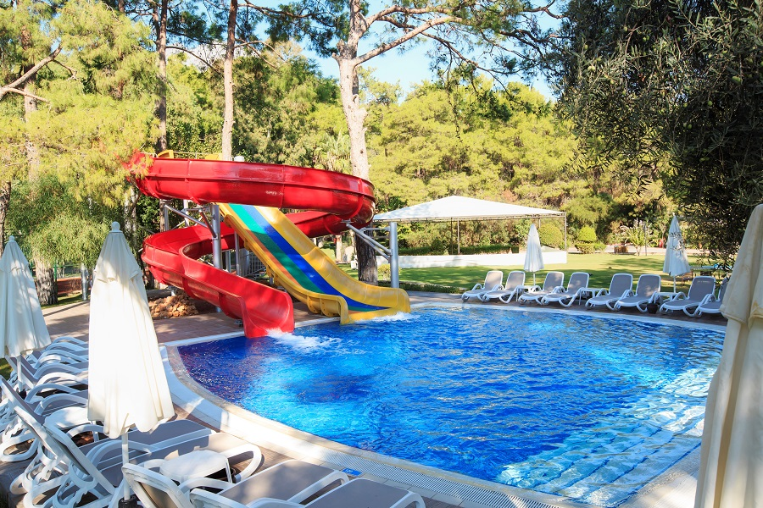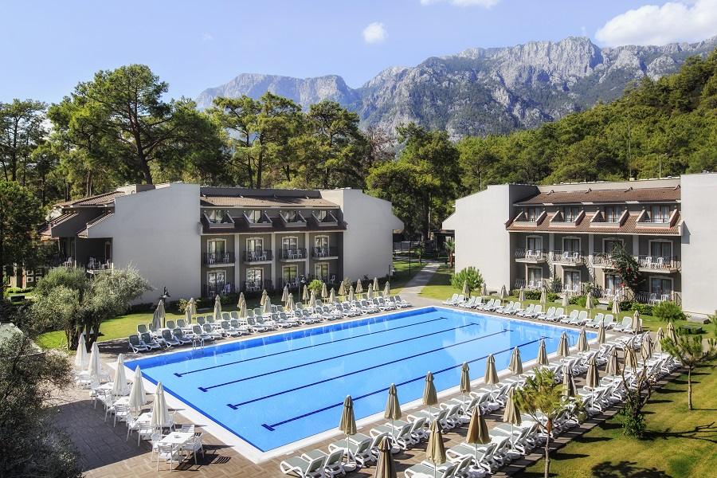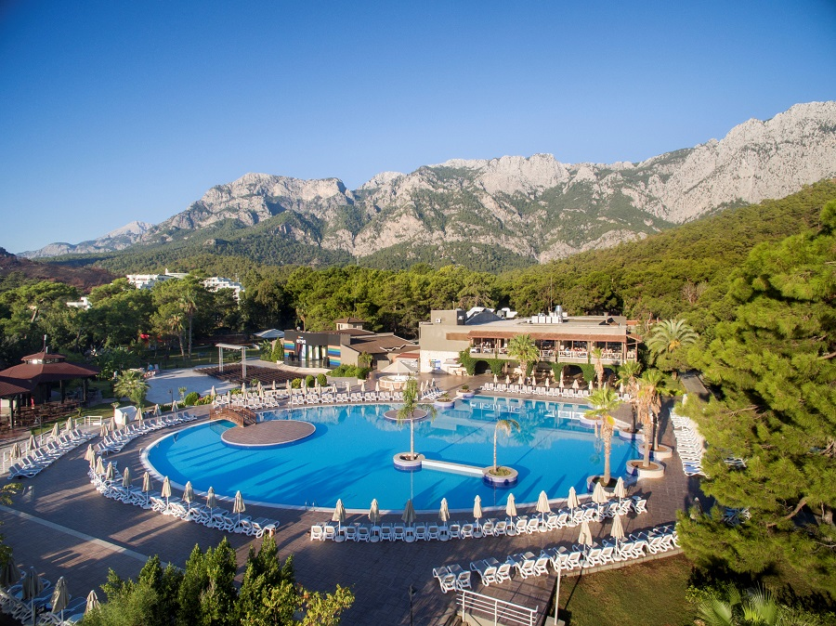
ACTIVITIES AND SERVICES
Daytime Animation
Basketball, boccia, beach volleyball, water gymnastics, mini football, table tennis, step aerobics, dance lessons, darts, tournaments, contests, tennis, zumba , yoga , plates
Evening Programs
Live music on certain days of the week, karaoke, sketches, theme nights, disco, gala night (shows and special shows), guest shows, surprise night shows, international shows groups, open air disco and magıc dj shows.
04-11 Age Group Children’s
7 days a week 10:00 to 12:30 / 14:30 to 17:00 / 21:30 to 23:00 hours between the mini club, various games, mini disco, hobby club, mini video, mini children's shows.
Free of Charge Activities
Tennis courts, table tennis, beach volleyball, basketball, mini football, sauna, Turkish bath, steam room, fitness room, surfing and catamaran (license is compulsory), canoeing (reservation), pedalo(reservation), international channels broadcast, backgammon, card games, all animation activities, Disco, aquapark and all use of pool, darts, beach towels, deck chairs, beach umbrella, in-room safe baby chairs in restaurants, Mini Club (gondola, carousel, Playstation), Wireless.
Chargeable Activities
Tennis courts lighting, tennis equipment, tennis lessons, jet skiing, parasailing, banana, ringo, water skiing, surfing lessons, water pipe.
Chargeable Services
Spa; Massage, peeling foam massage, hairdresser, laundry, business center, telephone, fax, copier, physician services, shopping centers, car and bicycle rental service, baby stroller, babysitting, private organizations (birthday parties, wedding anniversaries, etc.).
