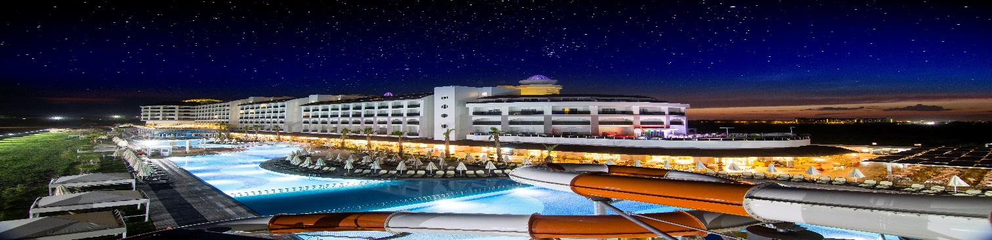
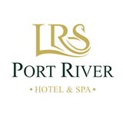
2020-21 WİNTER AI FACTSHEET
PORT RİVER HOTEL & SPA

Category : 5* Hotel
Address : Titreyengöl-Side- Antalya
Telefon no : 444 9 577
Fax no : 0(242) 744 15 70
E-Mail :info@lrshotels.com
Web Site : www.portriverhotel.com
Founded : 2015
Area : 25.000 m2
Capacity : 406 Rooms, 836 Beds
Languages : Turkish,English,German,Russian
Location : 250 metres
: To Side 7 km ,To Antalya 70 km,
To Manavgat 5 km,To Antalya Airport 65 km.
Transportion : Taksi, Mini Bus(Dolmuş)
Credit Cards : Visa,Master Card
Types on Room : 392 Standart Rooms,11 Family Rooms,3 Handicap rooms

Standard Double Rooms :392 Rooms – 16-25 m2 Min 1 - Max 3 pax
Stylish Rooms with; minibar (soft drinks)
satelite LCD TV,WLAN (Free of charge), radyo, direct dialingtelephone,
Split air condition, Safe (free of charge), laminate floring,
balcony, in bath shower & WC, make-up mirror, hair dryer(There is)a
double (french) bed.

Handicap Rooms :3 Rooms - 27 m2 - Min 1 - Max 2 pax
Stylish Rooms with ;minibar (soft drinks)WLAN,
satelite LCD TV, radyo,direct dialing telephone, Split air condition, Safe, laminate floring, balcony, in bath shower & WC, make-up mirror, hair, dryer. (There is) A double (french) bed. Handicap Rooms have Lake view and river view

Family Rooms :11 Rooms – 45 m2 - Min 2 - Max 4 pax
Stylish Rooms with; minibar (soft drinks)
satelite LCD TV, radyo,WLAN (Free of charge) direct dialing telephone, air condition, Safe, laminate floring,balcony, in bath shower & WC, make-up mirror, hairdryer.With two bedroom (there is) A double (french) bed in one of the room and twin beds other.

Accomodation : All Inclusive.
All Local drinks and Non Alcoholic drinks(specified below
according to the program free of charge 10:00-24:00
Breakfast | (open buffet) | 07.00 – 10.00 | Main Restaurant
Late Breakfast | (open buffet) | 10.00 – 10.30 | Main Restaurant
Lunch | (open buffet) | 12.30 – 14.30 | Main Restaurant
Patisserie |  | 16.00 - 17.00 | Bistro(Poolbar)
Dinner | (open buffet) | 18.30 -20.30 | Main Restaurant
Nights Soup |  | 23.30 -24.00 | Bistro

Bars
Lobby Bar 10.00-24.00 (Free of charge) Alcoholic and non alcoholic soft drinks
Disco Bar 22.00-24.00 (Frre of charge) Alcoholic and non alcoholic soft drinks(one day closed)

Sports
Fitness Center (Free of charge)
Table Tenis (Frre of charge)
Dart (Free of charge)
Pools
1 Indoor Swimming Pool
1 Children’s Pool(in door)

Shoping Center
Market,Hair Dresser,jewelry,Gift Shop,Boutique,Silver Shop,Shoe Store,Purse Store, Photos
Spa & Wellnes
Turkish Bath (Free of charge)
Steam Room (Free of charge)
Sauna (Free of charge)
Massage,wellnes center (with charge)
Peeling (with charge)
Health Care
Health Services (with charge)

Others
Safe(in Room) (Free of charge )
Beach Towel (Free of charge)
Sunbed (Free of charge)
Sun Umrella (Free of charge)
TV Room(Satellite) (Free of charge)
Telephone,fax,photocopy (with charge)
Baby Bed (Free of charge)
Laundry Service (with charge)
İnternet (in the Lobby Wireles) (Free of charge)
İnternet(in rooms) (Free of charge)
Room Service (with charge)
Orange Juice(Breakfast) (with charge)
Drinks Bottle (with charge)

Animation
Soft Animation (Free of charge)
Live Music(Some Evenings ) (Free of charge)
Disco (Free of charge)
Games Room
Billiards (Free of charge)
For Children
Children’s Buffet (Free of charge)
High Chair, (Free of charge)
Mini Club, (Free of charge) (04–12 years) (10.00-12.00/15.00-17.00)
İn Door Children’s Pool (Free of charge)
Baby Sitter (with charge)
Baby Buggy (Free of charge) (Reservation)

Electric: 220 V *No Pets Allowed.
**According to wheather conditions service times can be changed.

