**HOTEL FACT SHEET**

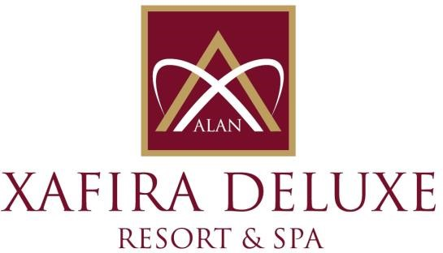

**G E N E R A L I N F O R M A T I O N**

**HOTEL NAME : ALAN XAFIRA DELUXE RESORT & SPA HOTEL**

**REGION : TÜRKLER TOURISM CENTER / ALANYA**

**REGION : 5 * DELUXE HOTEL**

**ADRESS : TÜRKLER MAHALLESİ, CUMHURİYET BULVARI ALANYA / ANTALYA / TÜRKİYE**

**TELEPHONE : 00 90 242 537 65 61**

**FAX : 00 90 242 537 65 62**

**WEB : www.xafiradeluxeresort.com**

**E- MAIL : sales@xafiradeluxeresort.com**

**TO**

**HOTEL TRANPORTATION :**

**DISTANCE METHOD DURATION**

|  |  |
| --- | --- |
| ANTALYA CITY TRANSFER | 110 km Bus 90 Min. |
| ANTALYA AIRPORT | 100 km Bus 80 Min. |
| ALANYA | 20 km Bus 20 Min. |
| SİDE | 50 km Bus 60 Min. |
|  |  |
| **ACCOMADATION:**  **TOTAL ROOM : 803** **ALL ROOMS ARE WITH:**  **TOTAL BEDS : 1718** Direct dial Telephone  Müsic System (Satellite)  Standart Room (Land and Sea View) : 640 ( 37m2 ) ( 1 french + 1 twin Bed ) LCD TV (Satellite)  Family Room (with folding doors – Land and Sea View) : 155 ( 46-50m2 ) ( 2 bed Rooms, 1 Dush-wc ) Baht Room  Handicap-Friendly Rooms (Land View) : 8 ( 34-37m2 ) ( 2 Twin Beds ) Mini bar & Safe | |
| **SPECIAL FEATURES:** | |
| Site Surface | : 45.000m2 Inside Suraface :18000m2 |
| Outdoor Pool | : 3.800m2 Children Pool: 75m2 |
| Outdoor Relax Pool | : 310m2 Aqua Pool : 250m2 |
|  | Children's Aqua Pool : 250m2 |
| Indoor Pool | : 120m2 (with heating system ) Only in the winter season |
|  |  |
| Xafira Main Restaurant | : 3.660m2 / 800 Person Indoor – 700 Person Outdoor **OPENING TIMES** |
| Ottoman Cuisine A’la Carte Restaurant | : 400m2 / 200 Person 19:00 / 21:00 ( PP 5 €uro ) |
| Italian Cuisine A’la Carte Restaurant | : 200m2 / 120 Person 19:00 / 21:00 ( PP 5 €uro ) |
| Fish Cuisine A’la Carte Restaurant | : 200m2 / 120 Person 19:00 / 21:00 ( PP 5 €uro ) |
| A’la Carte Open Time is  01.06.2024 -15.10.2024 |  |
| Game Hall | : Billard, Air hokey, Backgammon, Chess, Card games and Stone games |
| Wellness, Beauty Center / SPA | : Türk Hammam, Sauna, SPA, Special Massages, Beauty center **(private management)** |
| Mini club | : 80 m², for Children between 04 -12 years old |
| Shopping Center | : Jewellery, Mini Market, Hair Dresser, Boutique, Leather Shop, Silver, Souvenir, Photograph… |
| Ottoman meeting hall (all) | : 1350 m2 : Theatre Style 1100 person – Class Style 700 person, Ball Style 750 person |
| Info Hall 1 | : 108m2 : Theatre Style 100 person – U Style 60 person, I Style 40 person |
| Info Hall 2 | : 70m2 : Theatre Style 60 person – U Style 40 person, I Style 30 person |
| Meeting Room Equipment | : Barcovision, , Flip chart, screen, sound system, microphone… ) |
| Cleaning Service | : Daily room cleaning and room textiles change every 3 days |
| Beach | : 100 m. Long Sand & Pepple mixed privat beach |
|  |  |

**SPORT, FUN, HEALTH AND BEAUTY CENTER:**

**Extra Charged : Free of Charge :**

* Billard * Daily Activities (special games) * Animation Shows
* Cafe & Video Games * Turkish bath, Sauna, Steam Bath, Fitness Center
* Masagge & Peeling -Foam, * Table tennis, Dart, Beach Volleyball, Boccia
* Thai-Bali-Shiatsu-Massages * Step, Aerobic, Gymnastics, Water-Gym
* Beauty Center * Hair Dresser * Skin Care * Aquapark
* Water Sports (Parachute, Boat, Cano, Wind Surf) * Mini Club between 4-12 years old children. Mini Disco

**GUEST SERVICE:**

**Extra Charged : Free of Charge :**

* Doctor * Safe in Room
* Rent a Car and Jeep, Motocycles * Animation Shows
* Shopping Center * Wireless (Only in Lobby) * Exchange
* Airport Transfer * Mattress and Umbrellas at the Beach and Pool
* Room Service, Laundry * Beach Towel
* Telephone and Fax Service * Animation Shows
* Massage and SPA Service

**USE FULL INFORMATION:**

**\*\*\* Use full Credit Cards :** Visa & Master Card

**\*\*\* Languages :** Turkish is the official language. German, English and Russian are spoken.

**\*\*\* PETS ARE NOT ALLOWED.**