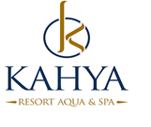

2025 SUMMER FACT SHEET & CONSEPT

Hotel Name : KAHYA RESORT AQUA & SPA
Category of the hotel : 5 Star
Address : Payallar Mah.Öztürkler cad.No:3 Alanya / ANTALYA
Telephone : 00 90 242 545 35 35
Fax : 00 90 242 545 40 33
Web Site : www.kahyaresorthotel.com
E-mail : info@kahyaresorthotel.com
Year Built : 2012
Renovation date : 2015
Number of Rooms : 447
Number of Beds : 1200
Hotel Area : 36000 m²
Pension (Board) : Ultra All Inclusive

Location
Airport : Antalya 110 km
City Center : Alanya City Centre 16 km
Next Town :Konaklı City Center 2 km
Hospital : 2 km
Transportation : Bus - Taxi - Minibus

Others
Credit Cards : Visa, Master
Pets : Not accepted
Voltage : 220

Rooms – Equipments
Total Number of Rooms : 447
Standart Room : 279 (34 m2 1 Single and 1 Doublebed, 1 sofabed)
Family Room : 144 (36 m2, 2 Rooms with connecting door, 2 Singlebed and 1 Doublebed)
Junior Suit : 21 (52 m2, 2 Rooms with connecting door, 2 Singlebed and 1 Sofabed for 2 Person, 2 Bathrooms)
Suit : 3 (65 m2, 3 Rooms with connecting door, 2 Singlebed and 1 Doublebed, 1 Livingroom, 2 Bathrooms)
Handicapped Room : 5 (3 Standartrooms / 1 Family Room /1 Jjunior.Suit )

Floor Covering : Laminate
Balcony : ✓
Bath Type : Shower
Air Condition : VRF-central
Hair Dryer : ✓
Telephone : ✓
Minibar : ✓ (The minibar will filled with water and mineralwater)
Safe Box : ✓ (extra charge)
Satelite : ✓ -40 sattellite broadcasts

Musıc : Tv musıc channel
Room Cleaning Periods : Daily
Bed Sheets/Towels : Every 2 days.
Beach Towels : Beach towels are changed once a day from the free towel desk.

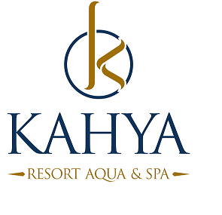

POOLS
2 Outdoor pool - 960 m2 -160 m2
Pool with slides ( 5 slides ) 120 m2
A children's pool, -95 m2
Pool River -580 m2
Space bowl-24 m2
(All pool and water slides are used according to the weather condition.)

Food & Beverage
Breakfast : 07:00 – 10:00 Main Restaurant Open Buffet
Late Breakfast : 10:00 – 10:30 Main Restaurant Open Buffet (limited)
Lunch : 12:30 – 14:00 Main Restaurant Open Buffet
Dinner : 19:00 – 21:00 Main Restaurant Open Buffet
Midnightsnack : 22:30 - 06:00 Patisserie

Bars
Lobby Bar : 24 hours (Local alcoholic, ,hot and soft drinks inclusive)
10:00 – 02:00 (some selected import drinks inclusive),

:02:00 – 10:00 (All import drinks for a charge),

Relax Bar : 10:00 -00:00 (Local alcoholic, hot and soft drinks)

Aqua Bar : 10:00 – 20:00 (Beer,Wine,hot and soft drinks)

: 20:00 – 00:00 (Local alcoholic drinks,hot and soft drinks)

Snack Bar : 10:00 -17:30 (Beer,Wine,hot and soft drinks)

Snack : 11:30-16:00

Coffee &Cake : 16:30 – 17:30

Bistro Pub Bar : 10:00-00:00 (Local alcoholic, hot and soft drinks)

Disco Bar : :00:00-02:00 (All drinks for a charge)

Beach Bar : 10:00 - 17:30 (Beer,hot and soft drinks)

Snack : 11:30-16:00

Patisserie : 15:00 – 18:00 (cakes,hot and soft drinks)

Beach

Access : 50 m.way through an underpass
Beach condition : sand / gravel
Seabed: : sand and rocks

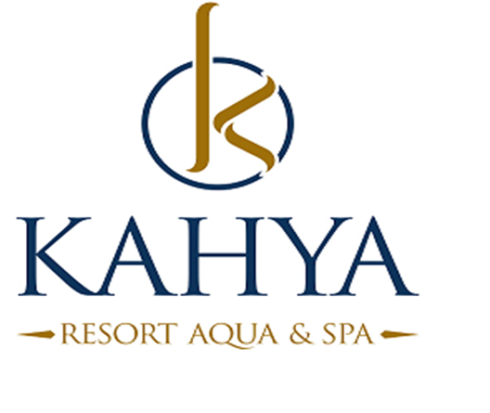
Entertainments

Daily Activities : Sport activities (water ball, beach volleyball, table tennis, archery, pool gymnastics,darts,pool games ) music,
Night Program : Show-time for the evening program
Kids Animation : Mini club activities (4-12 years-certain hours- 6 days a week)
(Entertainments 6 days a week)

CHARGEABLE AND FREE SERVICE
ACTIVITIES | DETAILS | EXTRA | FREE
Restaurants | Breakfast, lunch, dinner |  | x
Local drinks | All inclusive times |  | x
Import drinks | Only Lobby Bar 10:00-02:00 certain drinks |  | x
Fresh fruit juice |  | x
Room service |  | x
Safe box | In the room |  | X
Wireless | wifi is free in all area ( per person one device and speed untill 3 Mbps) |  | x
Ice Cream | Every day 11:00-12:00 and 15:00-16:00 o clock |  | x
Doctor service |  | x
Minibar | The minibar will filled with water and mineralwater. |  | x
Hamam |  |  | x
Sauna |  | X
Massage |  | x
A la Carte; Ottoman / Fish | One a la carte use for minimum 1 week  you will use A la Carte 1 order free./ with Reservation-by availability. A la Carte Restaurant is alternately open certain days of the week. |  | x
Fitness | 08:30-18:30(not allowed under 16 years) |  | x
Baby Bed and Chair | Based on availability |  | x
Water Slides / Aqua | 5 (certain hours) |  | x
Table Tennis | Based on availability |  | x
Disco | 24:00 till 02:00 |  | x
Disco | All drinks | X
Tv | 40 chanell |  | x
Beach Bar | Beer,hot and soft drinks |  | x
Umbrella and Sunbeds | Pool and Beach |  | x
Turkish Coffe |  |  | X
Laundry service |  | x
Late c/out | by availability | X
Flowers and Cake | Reservation by Guest Relation | x
Main Restaurant Capasite | inside 350 outside 500 pax |  | x
Meeting room Capasite | Max.300 pax |  | x
Market, jewelry store, hairdresser, boutiques, photo service, leather and fur store, souvenir shops, car rental, game center and tattoo salon |  | x
All activities can vary depending on the season and the weather.
Service hours are on the hotel’s own savings.
Paid activities fees may variable by hotel.
+In case of pandemic , services variability due to decisions of official authorities
may changeable.

