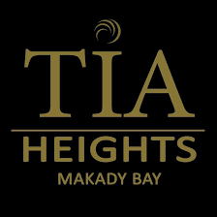
MEETS
WHERE
LUXURY
COMFORT
The Joy and beauty of unforgettable memories.

Tia Heights would like to complement your Makadi Bay experience by providing superb accommodation, impeccable service and attention to details.

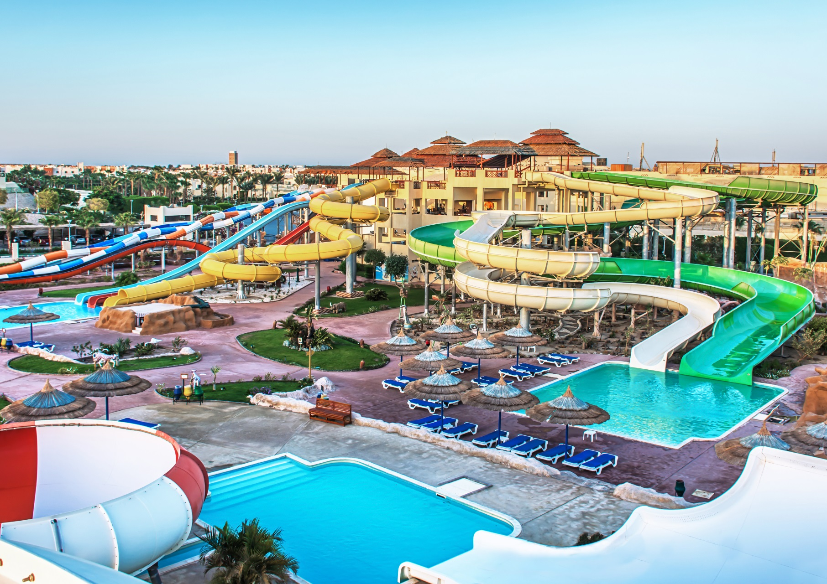

CONTENTS

- INTRODUCTION
- ABOUT
- TIA
- CASCATA

- FACILITIES
- AQUA PARK
- ROOMS
- OUTLETS
- ITALIAN RESTAURANT
- CHINESE RESTAURANT
- SEAFOOD RESTAURANT
- All INCLUSIVE

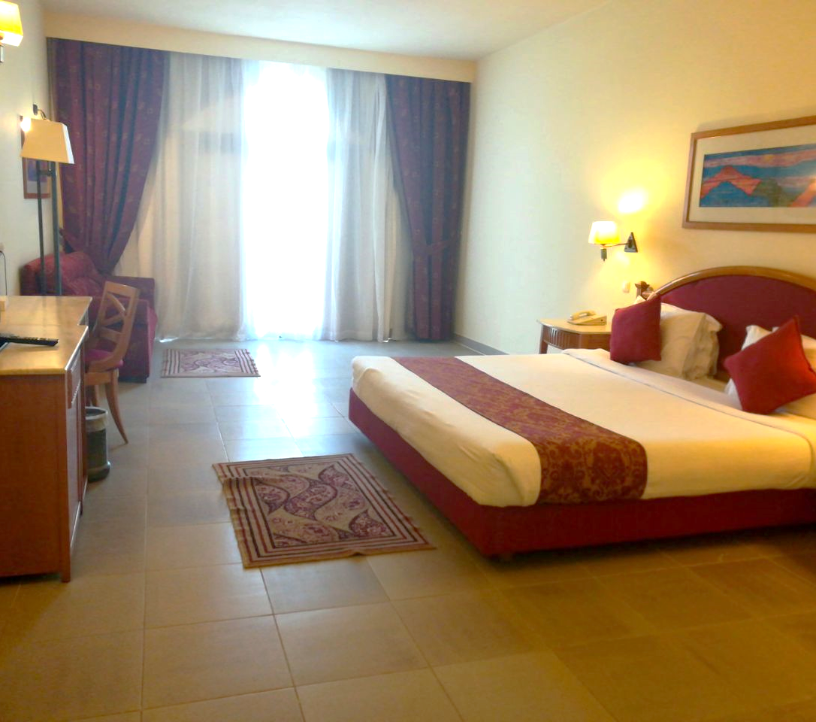

Tia Heights Makadi Bay
INTRODUCTION

From multicolored mountains and golden desert dunes, to the crystal blue water of the virgin Red Sea, Makadi Bay is set to bedazzle even the most seasoned traveler.
Tia Heights would like to complement your Makadi Bay experience by providing superb accommodation, impeccable service and attention to details.
Built over 250,000 square meters (from a total area of one million square meters), the resort boasts a 6,400 sqm swimming pool.
Location
The resort is located in the hearts of the breathtaking Makadi Bay area; it is a superb and fashionable destination in
Egypt nowadays on Hurghada –Safaga Road only 25 km away from Hurghada International Airport.
The resort faces 560 meters of pearly beach, blending with the blue crystal clear water, the virgin corals and the
Stunning Red Sea Mountains.

Built over 250.000 square meters (from a total area of one million square meters) the resort boasts 4 swimming pools, a 5.400 m². Main Swimming Pool that is considered the largest pool in the Middle East, TIA Club Pool, of 1000 m², Indoor Pool and Kids Pool. This is apart from the wide range of business & conference facilities available, the resort also offers a wide range of leisure and recreational facilities, so weather you are looking for place to relax and laze the days away or a little adventurous pursuit. Tia Heights Makadi Bay Hotel is the right place to be.
RESORT

ACCESS
Only 25 minutes away from Hurghada International Airport & 35 minutes from the city center Limos or
Shuttle buses are also available.

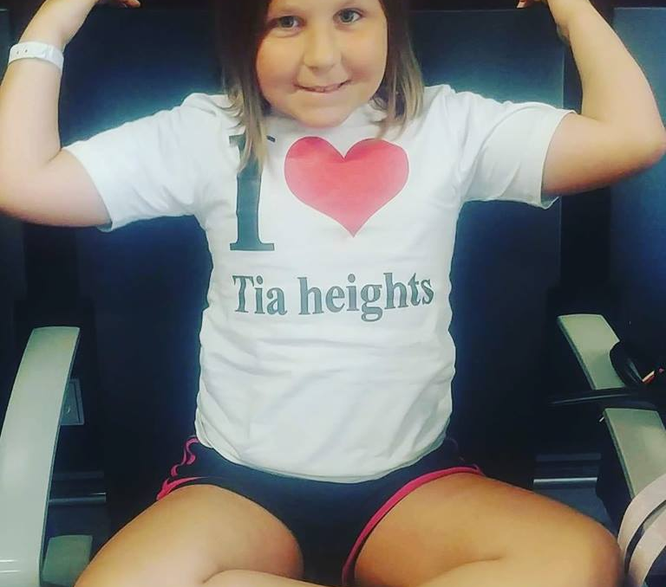
Sports & Recreation
- Huge outdoor swimming pool (5400 m²)
- Indoor heated pool
- Children’s pool
- Four International Tennis courts
- SPA
- Gymnasium
- Mini Golf course
- Sauna & Steam Bath
- Boccia
- Beach Volley Ball
- Nearby International Golf course
- Horseback riding
- Private marina
- Children Nursery
- Games room including (Table Tennis – Darts – Billiard – Video Games)

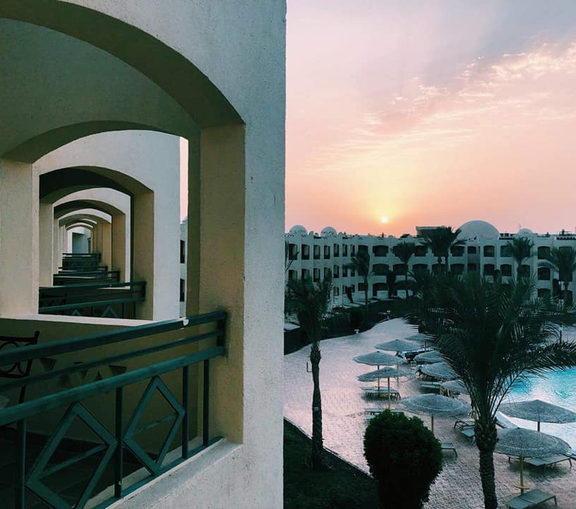

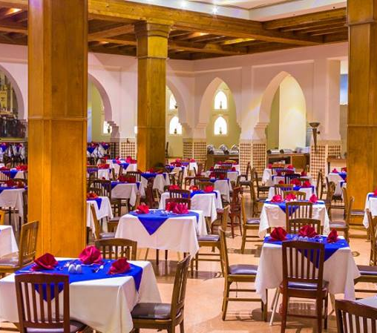

- I. TIA HEIGHTS

- (MAIN BUILDING)

The Hotel includes 474 guest rooms as follows:
451 Beach rooms -16 Superior Suite -7 Junior Suites
Tia Heights Hotel Room Facilities
- Individually controlled air conditioning
- International dial phone & voice mail
- Mini bar
- Private bathroom
- Hair Dryer
- Private balcony or Terrace
- Remote control satellite TV
- Safe Box
- Suites & Superior rooms its measurements range from 55 sqm to 274 sm, with very large balconies
- With a panoramic view.
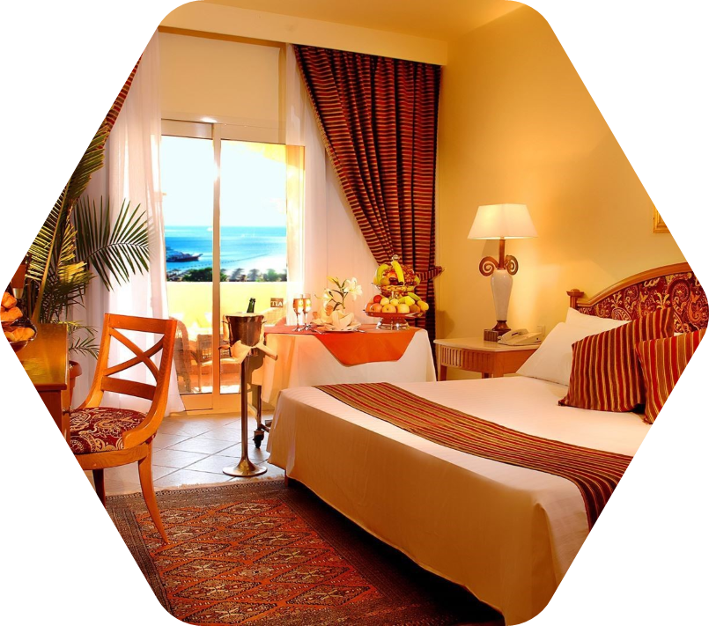

Restaurants & Bars
- Aladdin main Restaurant with different theme nights daily
- Prince Karim Restaurant
- Sunset Bar Upper Lobby Bar
- La Dauphin Lobby Bar
- Dockers Pub & Disco
- Caravan Beach Bar& Restaurant
- Seagull Beach Bar & Restaurant
- El Sayyad Sea Food Restaurant
- La Trattoria Italian Restaurant
- Blue Lagoon Pool Bar

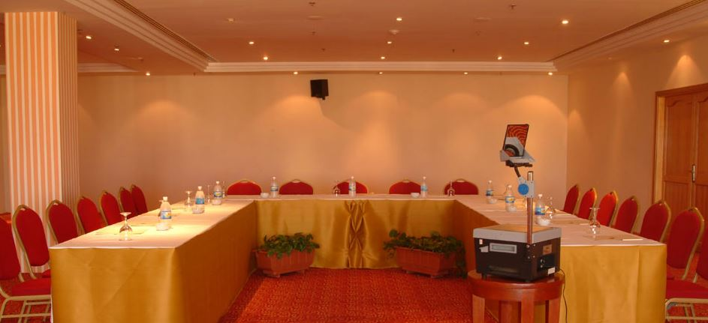
Conference & Meeting Facilities
For business travelers, the hotel caters all meeting and conference needs state of the art facilities that accommodate up to 420 delegate at “Makadi Ballroom” ensuring that every meeting a guaranteed success in addition to two breakout meeting rooms each is to accommodate up to 80 delegate.

II. CASCATA
Cascata Aqua include 342 Guest rooms with different room types to meet all expectations, Cascata Garden include 252 Guest rooms.
Cascata Aqua Guest Room Facilities
- Individually controlled air conditioning
- International dial phone & voice mail
- Mini bar
- Private bathroom
- Hair Dryer
- Private balcony or Terrace
- Remote control satellite TV
- Safe Box
Restaurants & Bars
- Aqua Main Restaurant with different themes night daily
- Caribbean Bar
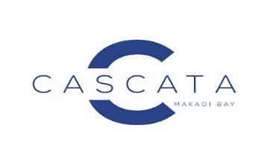
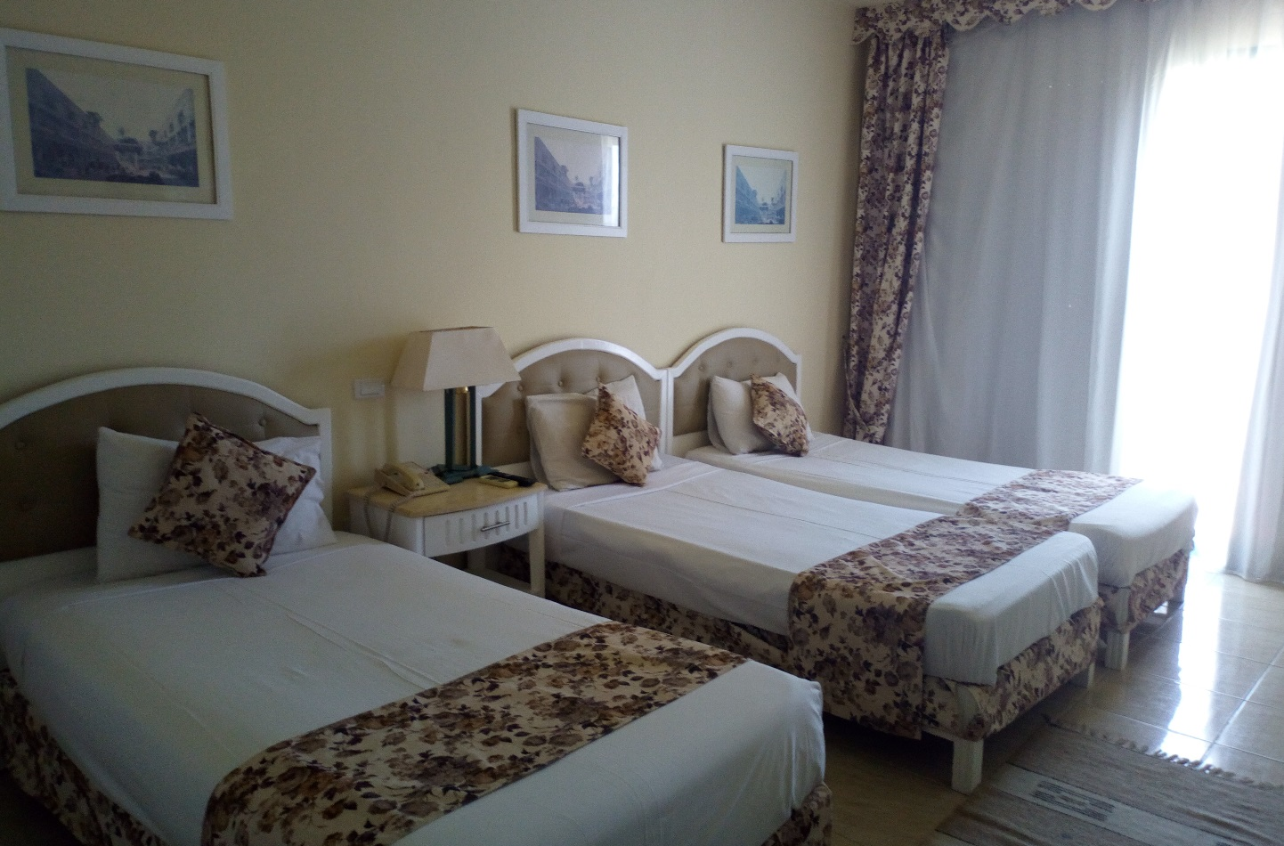
- Cascata Beach Bar
- Cascata Main Pool Bar
- Holiday Bar
- Dockers Pub & Disco

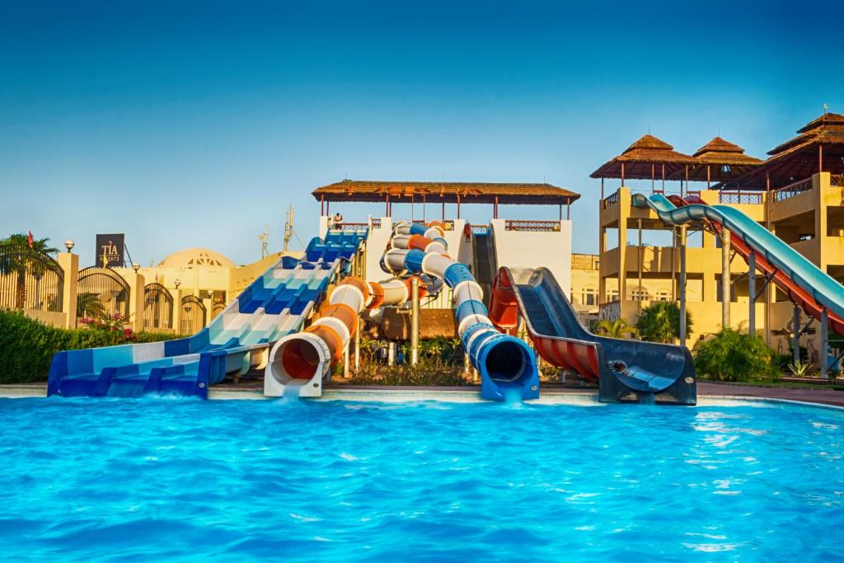

AQUA PARK

A warm welcome awaits you and your family when you visit the Red Sea area’s latest, largest and most exciting Aqua Park at Tia Heights Resort, Makadi Bay. This beautiful arena built, state of the art leisure attraction features Wave Pools, 17 fun inducing slides and a dedicated kiddie’s pool complete with its own aqua games. In between rides you can enjoy a tasty snack in one of the park’s food outlets or take a stroll along our own Jungle walkway, with its refreshing waterfall features and tropical landscaping – who knows, you may see an exotic “animal” or too also! There are plenty of sun beds and tropical umbrellas that provide welcome shady area so you can rest and relax and recharge your batteries before returning to your favorite slides yet again! Tia Heights Aqua Park is guaranteed to provide you with a great fun filled family day out, so don’t delay, visit us today!

OUTLETS

Varity is the spice of life and our over 9 fine restaurants and bars reflects this. Whether you fancy oriental cuisine from Egypt and the Far East, the freshest seafood, or inspired tastes from south of Italy, we have the menu and the ambiance to suit any mood. After dinner, if you like to disco, the Dockers serves delicious tropical drinks and the latest dance tracks until dawn, it is also ideal for those who want to catch a live show or simply try their luck at darts with its perfect combination of 5 star service, superb facilities and breathtaking landscapes, we hope you'll soon agree that Tia Heights Makadi Bay truly is a work of art enjoy your stay.
(Aladdin Restaurant - Caravan - Sunset bar - Aladdin pergola - Le Dauphin bar - El Sayyad restaurant - Safaga restaurant - Docker's Pub - Tea lounge)

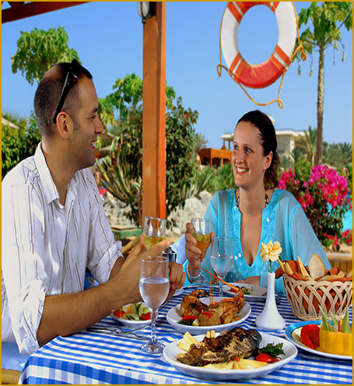

Italian Restaurant

Enjoy the delicious Italian cuisine with authentic Italian music and receipts. Daily from 19:00 till 21:00

Chinese Restaurant

You don’t need to travel abroad to Far East because in our restaurant you can go to China even if you are still here. Daily from 19:00 till 21:00

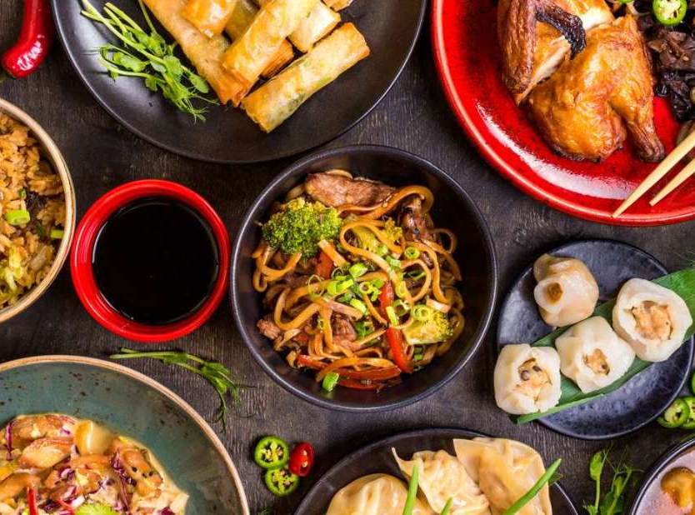

Seafood Restaurant

Enjoy the taste of the sea with our authentic seafood restaurant. Daily from 19:00 till 21:00

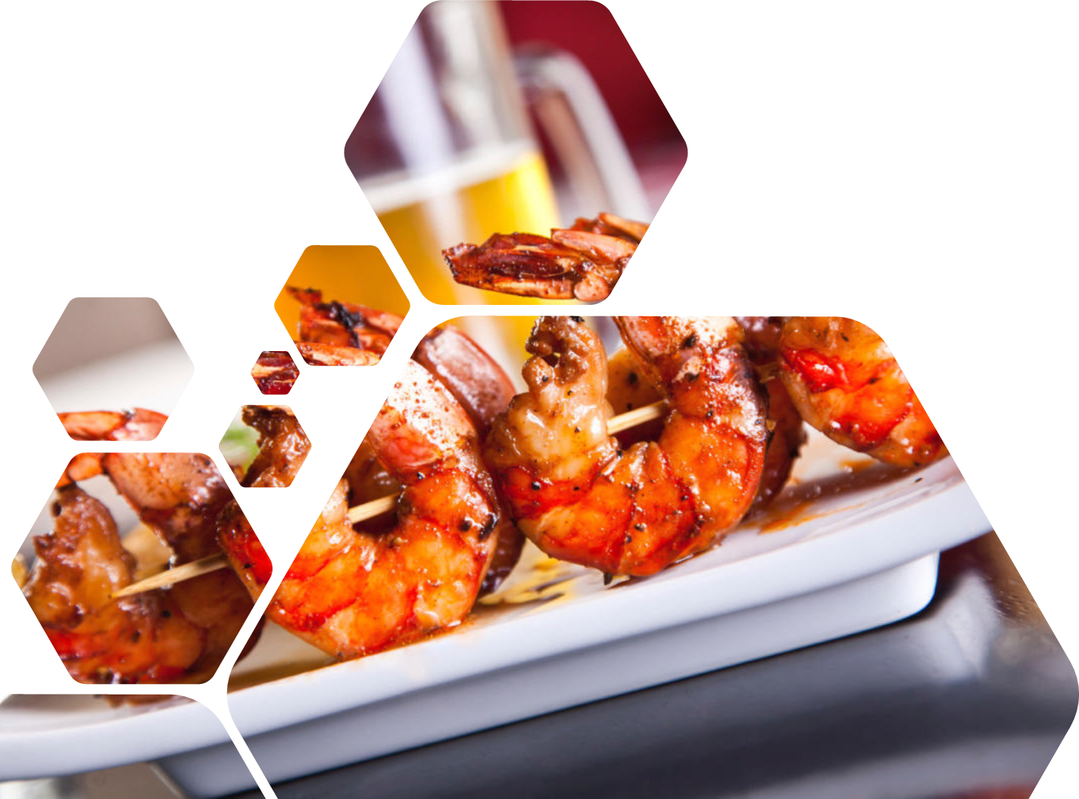

ALL INCLUSIVE

Other A-la Carte Restaurants reservation are required a day in advance through the reservation desk in the lobby (7 DAYS MIN.M)
The Extra: In Case of food allergies contact the restaurant chef.
Check out time 12:00 noon. Staying in the room after 12:00 noon is possible according to the hotel availability, and will be against an extra charge, please contact reception to arrange all necessary details.
Any damage found in the guest’s room will be charged and must be settled before departure.
Attention! Please return your room key& towel cards to the reception by 12.00 noon. In case you lose either Beach Towel or Beach Towel Card, you will be charged 100 LE.
Animation Day Programs: from 10:00 till 13:30 and from 15:00 till 17:00 (Sport activities and kids club)
Kids Club – 10:00 till 13:00 / 15:00 till 17:00
Animation Evening Programs:
-Mini disco and kid’s cinema: 19:30 -21:30 Hrs. (Dockers’ Bar) at the lobby.
-Show Time: 21:30 till 23:00 in the Dockers Bar
-Disco (Adults): 23:00 till 02:00 In the Dockers Bar.
Activities: GYM 08:00 - 20:00 Hrs.
Tennis court is free 1 hour per day, without equipment's.
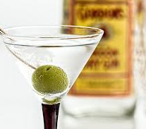
Aqua Park: 10:00 – 12:00 & 13:00 -16:00

Free Ice-cream In LAGOON POOL BAR 14:00-16:00
Room Mini Bar: provided daily with two big bottles of mineral water.
Medical Service: The hotel doctor is available 24 Hrs.
Dress Code: As a courtesy to other hotel guests a proper dress code should be respected.
Please utilize the safe box located inside your room or in the reception (free of charge). Do not leave your personal things outside your room/terrace/balcony! The hotel management will not be responsible for any loss.
Lost Safe Box Key: In case you lose your safe deposit box key, you will be charged the amount of 1200 LE.

Guest room linen: Kindly leave hotel Towels, Pillows & Blankets in the room while going on excursions in order to keep it in good state for usage. Special pillows for excursions are available at Reception (free of charge).
-Dear Guest prior to low season in Winter You have to open the hot water tap for 10 minutes before usage

OTHER ACTIVITIES

- Indoor swimming pool
- Table Tennis
- Animation Team Program
- Kayaking
- Diving center
- Sauna and steam Bath
- Private Marina
- Sailing
- Beach Buggy safaris
- Sea Trips
- Golf Courses ( nearby )
- Horseback Riding
- Water Skiing
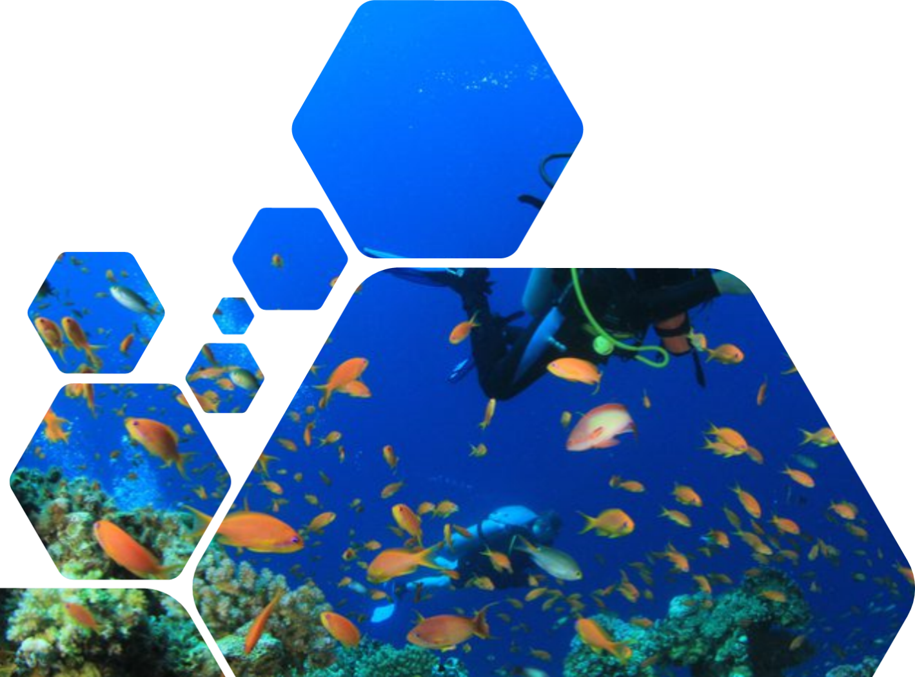
- Mini Golf Courses
- Game Room Included
- Desert Safaris
- Mountains Excursions
- Spa Center

