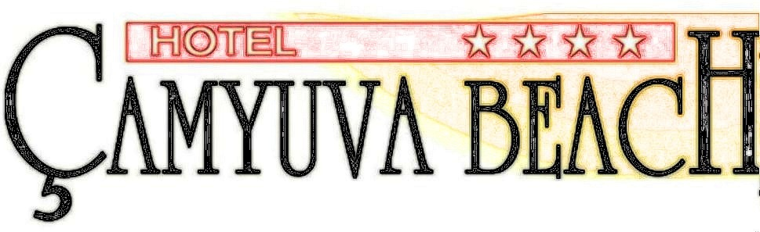
ALL INCLUSIVE 2023
Dear guests,
İf you look inside of our Stars . You will find Trust, service , relax and fun .Welcome To Camyuva Beach ****+

LOCATION: .
Hotel located the area of Camyuva/Kemer,60 km far from Airport ,50 km from Antalya ,6 km from Kemer
Beach located 150 metres from the hotel. Hotel Camyuva Beach has a blue flag certificate in own beach

ACCOMMODATION: .
Hotel has , 2 rooms for disabled , 177 Standart rooms and totally 179 rooms.

ROOMS: : .
Each rooms has its own balcons, Wc, shower , parquet floors,32 “led Tv , minibar, Mitsubishi Split air condition , Direkt telephone, telephone in bathroom , hair dryer,baby cote(when needed)and safe box (with payment). Wi-Fi internet (with payment just in rooms) internet use in lobby flor free .

ACTIVITIES: .
We are trying to make you happy with our special activities.Soft Animation programe. darts, table tennis, bocca ,water polo, mini club (03-12 ages), ,2 open swiming pool, 2 water silides for adaults ,1 children pooland 1 water slides for children , sauna (13.00 – 17.00) extra 5 €, ,Turkish bath (09.00 – 22.00) extra 5€ , fitness center , beach towels (with deposit 10$), message (with payment), billiards (with payment), table football (with payment), air football (with payment),and Wi-fi internet Free ( just in Lobby Flor)

MEETING: : .
Hotel has a meeting saloon for 50 person. With all equipments .

ALL INCLUSIVE FOOD AND BEVERAGES: .
Iso 22000 H.A.C.C.P certificated by TÜV

Internatıonal kitchen ,There are 2 restaurants.Inside restaurant,Outside (teras) restaurants . Rich , big open büffet services.Open breakfast büffet, open late breakfast büffet, open lunch büffet, open dinner büffet serving. Daily snack büffet (pool bar), coffee and tea time also beverage services.

BARS: (After 22:⁰⁰ night all local and import drinks with payment ) .
Beach bar All soft drinks , alcohol :red/white/pink wine (08:⁰⁰—18:⁰⁰)
Pool bar All local drinks, daily snack büffet(free)&import drinks (with payment). after 22^{.00} all drinks extra (10:⁰⁰—23:³⁰)
Lobby bar All local drinks free (10:⁰⁰—22:⁰⁰) after 22^{.00} all drinks extra (10:⁰⁰—22:⁰⁰)

You Will Fell Better With Us !

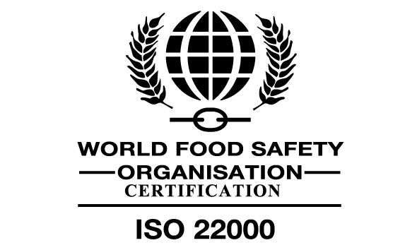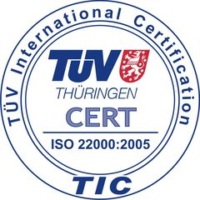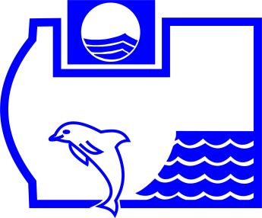

HOTEL ÇAMYUVA BEACH www.hotelcamyuvabeach.com
Çamyuva Mah Necmi Can Cad No:3 – Kemer/ANTALYA TEL:+90 242 8247720 FAX:+90 242 8247721 info@hotelcamyuvabeach.com

